**JSS MAHAVIDYAPEETHA, MYSURU**

**JSS Academy of Technical Education**

JSS Campus, Uttarahalli Kengeri Main Road, Bangalore - 560060

**Department of Information Science and Engineering**

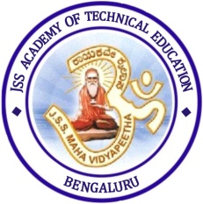

**CERTIFICATE**

This is to certify that the project work entitled **“Personalized Movie Database”** is a Bonafied work carried out by **Mr.** **ADITYA PRIYADARSHI (1JS15IS004)**, **Mr.**  **ABHISHEK VERMA (1JS15IS003)** in partial fulfillment for the DBMS Laboratory with Mini Project (15CSL58) of 5th semester **Bachelor of Engineering** in **Information Science and Engineering** of the **Visvesvaraya Technological University, Belgaum** during the academic year 2017 - 2018. It is certified that all corrections and suggestions indicated for Internal Assessment have been incorporated in the report deposited in the department library. The project report has been approved as it satisfies the academic requirements in respect of project work prescribed for the said degree.

## Mrs. Mamatha G Dr. Dhayanand P

## Asst Professor, Dept of ISE Associate Professor, Dept of ISE

## 

## 

#### Name of the Examiners Signature with Date

**1)…………………………… ………………………**

**2)…………………………… ………………………**